## Daily Temporary Storage

* Live an eventful life. Drop off your bags in between events then pick them up when you're free.
* Live your life freely. Drop your stuff off when you don’t need it at a nearby Caddy location. We’ll hold it safe and sound until you’re ready to have it delivered directly to your door.

Image:

(Locker): <http://icons.iconarchive.com/icons/uiconstock/e-commerce/256/locker-icon.png>

(Sun): <http://cdn.apk-cloud.com/detail/image/com.samymarboy.theme.sunshine-w250.png>

## Sleepy-Time Storage

Store your valuables overnight, we'll read them a bedtime story.

Image:

(Sleeping): 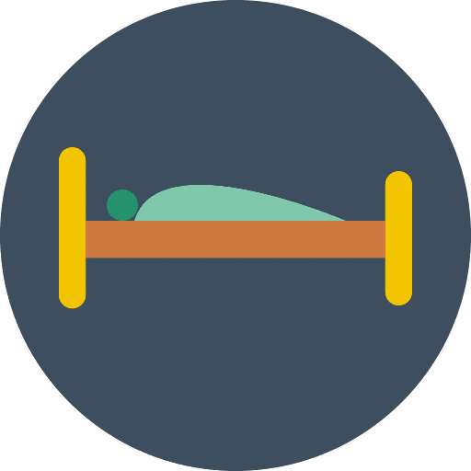

## Happy Hour Calls

* Work is over! Drop those bags in storage and enjoy your night. Request to have your bags delivered to you in the morning.
* Work is over! Drop your bags with Caddy and enjoy your night. Request to have your bags delivered directly to your door in the morning.

Image:

(Soda): <http://icons.iconarchive.com/icons/graphicloads/food-drink/256/drink-icon.png>

(Wine): <http://icons.iconarchive.com/icons/graphicloads/food-drink/256/drink-4-icon.png>

## Exercise Just Got Easier

Leave your gym clothes where you need them, there's no need to lug around that heavy gym bag.

Image:

(Stretching man): <http://www.freeiconspng.com/uploads/exercise-icon-1.png>

(Gym bag): <https://cdn0.iconfinder.com/data/icons/sports-and-fitness/512/bag_sport_sports_gym_equipment_accessory_baggage_modern_fitness_training_athletic_travel_flat_design_icon-512.png>

## ~~\\\\\\Track Your Belongings~~

~~Label your stored belongings on your app. Track their location and never lose your things again.~~

~~Image:~~

(Pin): <http://ph.garmin.com/minisite/vivo/vivoactive/images/vivoactive-features-icon-large-gps.png>

(Gps device): <http://icons.iconarchive.com/icons/flat-icons.com/flat/256/GPS-icon.png>

(Huge pin on map): <http://lh3.googleusercontent.com/ZYMhmlenPKoIYdnoi_XfDsgDg1xnK64571yToUysqre0zgytXzb-w7y2HMEYj-6qBbE=w300>

## Convenience Like Never Before

We partner with businesses all around you. Whether you're headed to your gym, playing frisbee in the park, or shopping with your friends, use the Caddy app to find secure baggage storage where you need it.

Image (Pin drop on map): <http://med-project.org/wp-content/themes/medproject/css/images/map-icon.png>